What is technology transfer?

Technology transfer is a key component in the economic development mission of Missouri University of Science and Technology. Technology transfer complements the research mission of the university by providing a path to move innovative discoveries to commercial companies to further develop the technology and make it useful for mankind.

What is Missouri S&T technology transfer?

The campus technology transfer office (TTO) is a university service unit composed of specialists in licensing, business development, and legal matters with experience in transferring technologies to the marketplace. In support of the university’s economic
development mission, the TTO serves as the focal point for entrepreneurship, economic development, and
technology transfer and actively brings together the organizations, resources, and processes to efficiently and effectively move research results into the marketplace. As generally shown in the flowchart on page 2, the process typically includes:
- Evaluating new technologies
- Protecting technologies through patents and copyrights
- Forming development and commercialization strategies (marketing and licensing to
existing private sector companies or creating new startup companies based on the technology)

Why would a researcher want to participate in the technology transfer process?

The reasons are unique to each researcher and may include:
- Making a positive impact on society
- Feeling a sense of personal fulfillment
- Achieving recognition and financial rewards
- Generating lab or departmental funding
- Meeting the obligations of a research contract
- Attracting research sponsors
- Creating educational opportunities for students
- Linking students to future job opportunities

How is technology transferred?

Technology is typically transferred through a license agreement in which the university grants its rights in the defined technology to a third party for a period of years, often limited to a particular field of use and/or region of the world. The licensee (the third party licensing the technology) may be an established company or a new business startup.

Licenses include terms that require the licensee to meet certain performance obligations and to make financial payments to the university. These payments are shared with the inventors and are also distributed to the schools/ colleges, departments/units, and central administration to provide support for further research, education, and participation in the technology transfer process.
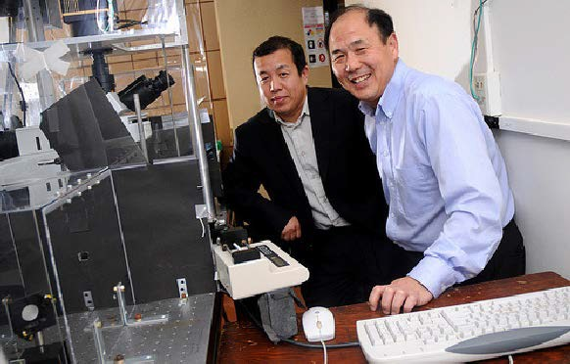

How does a researcher work with the university’s technology transfer office?

A researcher should contact the TTO early to be aware of the options that will best leverage the commercial potential of the research. The technology transfer staff are trained to assist inventors with questions related to marketability, funding sources, commercial partners, patenting and other protection methods, new business startup considerations, university policies and procedures, and much more. This team approach provides researchers with an assigned licensing specialist supported by internal legal assistance and, if a new business startup is being considered, business development resources as well.

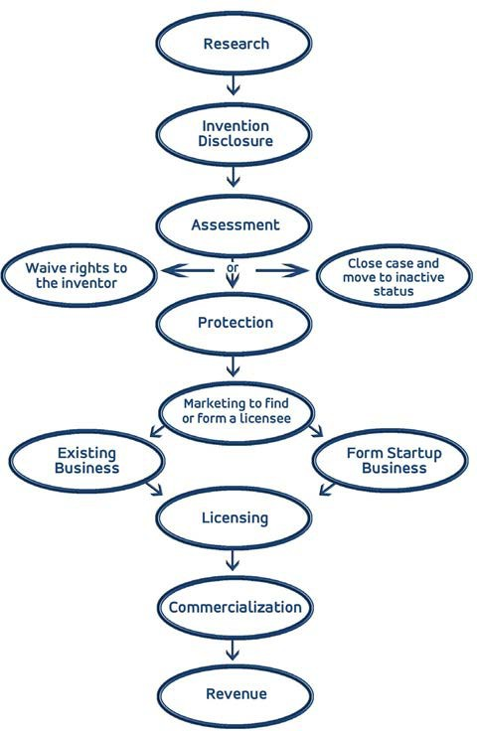
Triage
Technology Transfer Process
A thorough review of the development history is conducted to determine, among other things, ownership of the invention, existence of any contractual rights and obligations that may impact the university’s ability to patent and/or commercialize the invention, and any potential bars to patenting. In addition, an evaluation of the technology’s stage of development is conducted. Determining whether the technology is just a concept or a complete invention influences when, and if, a patent application will be filed.

Intellectual Property Analysis
An evaluation is conducted to determine the novelty of the invention and identify any issues that may impact the patent decision.

A preliminary search of patents and literature is conducted to identify prior art that could impact the scope of a patent application. An assessment is also conducted of any public disclosures of the invention to determine their potential impact on patentability. Public disclosures could be in the form of articles, slides, poster presentations, theses, electronic information, and grant proposals and awards. If the IP analysis indicates that novelty is clear and can be defined broadly, the university is more likely to consider filing a provisional patent application and conducting a market study.

What are the typical steps in the process?
Upon receipt of a complete invention disclosure form, the university will conduct an evaluation to fully assess the potential patentability and marketability of the invention. The flowchart above illustrates the evaluation process. It is expected that decisions will be made within the indicated time periods; however, unforeseen circumstances may require adjustments to the time periods in some cases.
Note that these steps can vary in sequence and often occur simultaneously.

Market Analysis
A comprehensive review of the potential market for the invention is conducted. This analysis looks at the advantages and disadvantages of the invention as compared to existing products/services in the marketplace. Market size and the ability to capture market share are also investigated. During this process, other uses and markets for the invention may be identified.

The market analysis will also consider issues that may impact the value of the technology to a potential licensee, including development needs and the associated costs. The goal of this analysis is to determine the market strength of the invention and determine whether IP protection would likely result in a licensed commercial product. If the market is small and prospects for licensing are low, investing in a patent application may not be advisable.

Decision Points
At certain time intervals, or when a patent filing or other deadline is approaching, the university will review all the available information to determine whether to proceed with patenting and/or commercialization of the technology.

All factors that may impact the potential to generate a return of an investment in the technology will be taken into consideration. At each decision point, possible outcomes include: file a provisional patent application; market, or continue to market, the invention to potential licensees; hold for additional research; waive/offer the invention back to the inventor; or close the file and move it to inactive status.

Market to Potential Licensees
This is one of the most critical elements in making a decision whether to pursue patenting and commercialization of a technology. At this stage, the university will contact potential licensees to determine their interest in taking a license to the invention. If interest in the technology is expressed by a company, the university will share confidential information with the company only after a provisional patent application has been filed and/or the company has signed a non-disclosure agreement. The decision to file a non-provisional patent application only makes sense if the university believes that the patent will be licensed and revenues will come back to the university to, at a minimum, cover the expenses incurred with patenting. Therefore, a clear potential market and strong indication of being able to find a licensee are needed prior to filing a non-provisional patent application.

Filing for a Patent
Provisional patent applications can be filed in-house by the Office of Intellectual Property Administration. If a decision
is made by the university to file a non-provisional patent application, outside patent counsel will be retained and the university will cover the costs of preparing and filing the application. An inventor will be expected to complete and sign all necessary documents and work with the university and its patent counsel to ensure that the full scope of the invention is contained in the patent application.

Option/License Negotiations
If a company expresses interest in taking an option to license, or entering into a license agreement, the university will negotiate the terms of such agreement. Inventors will be notified that a company has expressed interest and inventors will be kept abreast, with an opportunity to provide input, as the negotiations proceed.

Receipt of Revenues
In accordance with the university’s collected rules, an employee of the university is entitled to thirty-three and one-third percent (33.3%) of revenues the university receives through the transfer of rights in the invention (i.e. license, option, etc.). For plant varieties, the inventor shall receive ten percent (10%) of such revenues. The complete policy on distribution of revenues, and other
policies related to patents, can be found in section 100.020 of the University’s Collected Rules & Regulations.
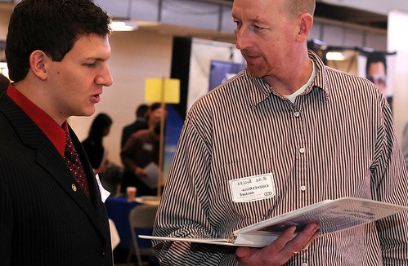

How long does the technology transfer process take?

The process of protecting the technology and finding the right licensing partner may take months—or even years—to complete. The amount of time will depend on the development stage of the technology, the market for the technology, competing technologies, the amount of work needed to bring a new concept to market-ready status, and the resources and willingness of the licensees and the inventors.

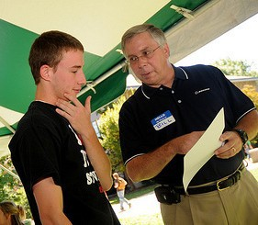
How can I help in this process?

- When you believe you have created or discovered something unique with potential commercial or research value, contact;
  - Keith Strassner, Director at (573) 341-6725

kdstrass@mst.edu
  - John Woodson, Senior Licensing & Business Development Specialist, at (573)-341-7554 jwoodson@mst.edu
  - Casey Gideon-Saladin, Business Manager at 573-341-7263 gideonc@mst.edu
- Complete and submit the Invention Disclosure Form before publicly disclosing your technology or submitting a manuscript for review and publication. The form is available at http://ecodevo.mst.edu/info/tto-home/tto-forms/
- To avoid risking your patent rights and possibly hindering the opportunity to market your invention, contact the technology transfer office before holding any discussions with people outside the university community.
- On the Invention Disclosure Form, include companies and contacts you believe might be interested in your invention or who may have already contacted you about your invention. Studies have shown that over 70 percent of all licenses are executed with commercial entities known by the inventor, so your contacts can be extremely useful.
- Respond to the technology transfer office and outside patent counsel requests. While some aspects of the patent and licensing process may require significant participation on your part, we will strive to make efficient use of your valuable time.
- Keep technology transfer informed of upcoming publications or interactions with companies related to your intellectual property.

How are license revenues distributed?

The UM System Office of Intellectual Property Administration is responsible for distributing the revenues associated with technology license agreements. Under the university’s Collected Rules and Regulations, one-third (33.3%) of revenues from license agreements (fees, royalties, etc.) are distributed to the inventor(s). To review the complete policy, visit: http://umsystem.edu/ums/rules/collected_rules

What are the tax implications of any revenues I receive from the university?

License revenues are typically taxed as Form 1099 income. Researchers who receive such revenues should consult a tax advisor for specific advice.

How are inventor revenues distributed if there are multiple inventors and/or multiple inventions in a license?
While there may be some variation in the procedure, typically when a license agreement is negotiated, a revenue distribution plan (RDP) is created to document the formula used to distribute any subsequent revenues. The initial RDP includes a draft formula based on the contributions listed in the Invention Disclosure(s) related to the license.
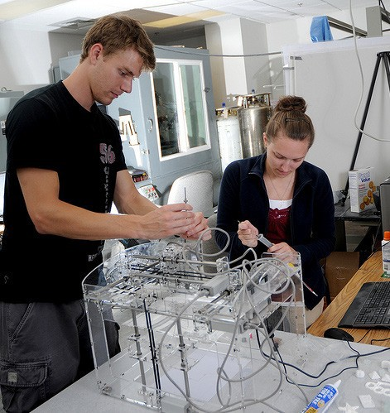
Technology transfer asks one inventor within the group to serve as coordinator and to report the percentages determined by the inventors collectively. All inventors must sign the RDP, signifying their approval. Should the inventors be unable to agree on an RDP, revenues will be distributed equally or retained until agreement is reached.

How is equity from a license distributed?

In some cases, as part of a license, the university may obtain an equity interest in a licensee. When university equity is liquidated, the resulting funds are distributed in accordance with the revenue distribution plan and the university’s Collected Rules and Regulations.

What is the Bayh-Dole Act?
The U.S. Bayh-Dole Act of 1980 allows universities and other non-profit institutions to own rights to discoveries resulting from federally funded research, provided certain obligations are met. These obligations include making efforts to protect (when appropriate) and commercialize the discoveries, submitting progress reports to the funding agency, giving preference to small businesses that demonstrate sufficient capability, and sharing any resulting revenues with the inventors. The Bayh-Dole Act is credited with stimulating interest in technology transfer activities and generating increased research, commercialization, educational opportunities, and economic development in the United States.

What are the most relevant Collected Rules & Regulations when it comes to technology transfer?

100.020 Patent and Plant Variety Regulations
100.030 Copyright Regulations
330.015 Policy on Conflict of Interest
420.030 Conflict with the Interests of Federal Grant Agencies
410.020 Institutional Conflicts of Interest in Human Subjects Research
To review these policies, visit:
http://www.umsystem.edu/ums/aa/oipa/policies

This information is taken from the University of Michigan’s “Inventor’s Guide to Technology Transfer,” with adaptations for the University of Missouri. We are very grateful to Ken Nisbit and the staff of the University of Michigan Office of Technology Transfer for granting permission to use their excellent material and to the University of Michigan for permission to use its copyright.

